2021

3rd Annual

***North Fort Myers Civic Association / Signarama - North/ All American Printing Whiffle Ball Bash - 2021***

**Tournament Date: Saturday May 22, 2021 / Opening Ceremony 8:50 am / Regular Season Games 9:15am-2:00pm / Playoffs 2:15pm -3:00pm / Championship Game 3:00pm – 4:00pm (Gates Open at 8:00 am)**

**Location: North Fort Myers Community Park (Football Field) 2000 Recreation Park Way N. Ft. Myers**

**\*\*\*\*\*\*\*\*\*\* *COVID 19 SAFETY MEASURES WILL BE IN PLACE FOR 2021*\*\*\*\*\*\*\*\*\*\*\*\***

The North Fort Myers Civic Association / Signarama- North / All-American Whiffle Ball Bash is presented by the North Fort Myers Civic Association, along with Title Sponsor Signarama North /All-American Printing, to benefit and fund the North Fort Myers Civic Association’s Non-Profit community initiatives and community projects.

The event is open to anyone who wants to play, spectate, or volunteer. Our Inaugural tournament in 2019 hosted 16 teams and was a tremendous success resulting in the largest fundraising event ever for the North Fort Myers Civic Association to date. It was followed by another outstanding tournament in 2020 which surpassed the 2019 fundraising goals. We hope 2021 will be even better.

The Whiffle Ball Bash will consist of Regular Season, Playoff, and Championship Games.

Ages range from 8 to 88+ and those of all genders are encouraged to play.

Teams will consist of a minimum of 3 players to a maximum of 5 players. ***Every player will play in every game at the Whiffle Ball Bash***.

Cost to enter the Whiffle Ball Bash is only **$100** per team on an assigned team minimum of 3 players.

Don’t have a team – No problem. Individual players may sign up to play in the Whiffle Ball Bash for only $25. *The tournament committee holds the right to assign an individual player to a team consisting of 3 or 4 players or form a team consisting of individual players.*

**Tournament Play**

Divisions will be assigned to offer the most competitive and fair competition for anyone who wants to play. So, put together a team of co-workers, friends, family, club members, or one of the many other combinations out there, and come out to compete in this family friendly event that anyone of any skill level can enjoy. No experience is necessary at the Whiffle Ball Bash. **We are looking to add a special Public Safety Division to include Law Enforcement, and Fire Rescue teams.**

Teams are placed into 4 separate divisions. Teams will play each team in their respective division in the regular season. All regular season division games are 4 innings or up to a 35-minute time limit (extra innings if tied), whichever comes first.

The 4 regular season division winners will compete against each other in in the playoffs. Playoffs will begin after regular season play. Playoff teams are guaranteed 2 playoff games, a first round playoff game, as well as a Championship Game and a Bronze Medal game depending on their first round playoff game result. First Round Playoff games are 6 innings or a 45 minute time limit (extra innings if a tie) . Championship and Bronze medal games are 7 innings or until a winner is determined. **The Tournament will be a 1-day event.**

*N****o Base Running will be needed at the Whiffle Ball Bash*.***

The Whiffle Ball Bash will be a recreational tournament following rules as determined by the host and as listed in the official tournament rules packet, in which every team captain will receive.

The winning team of each regular season division will receive a Division Champion Pennant for each team member. A Team Championship Trophy will be given to the tournament winning team along with an individual trophy for each 1st place team member. A 2nd and 3rd place team trophy will be given for the 2nd and 3rd place overall teams along with Silver and Bronze medals for each individual player. A certificate of player participation will be given to all players participating in the Whiffle Ball Bash.

*A special field will be set up for kids ages 5-12 from 1:45pm to 4pm and a Junior Home Run Derby will be held* ***free of charge for the kids*** *with a chance to win great prizes.*

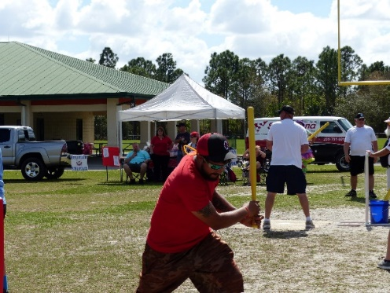**.** 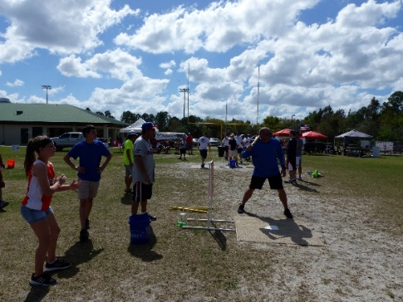

**Whiffle Ball Bash Experience:**

Bring out your family, friends, co-workers, and anyone else to cheer your team on to victory. Fields will be designed to allow for a fan friendly atmosphere. Chairs and blankets will be allowed as well as small shade tents for fan and team comfort. **Concessions will be available.** Other subsidiary events may be held at theWhiffle Ball Bash to enhance the tournament and fan experience as well. ***Spectator admission is free of charge. However, donations are always greatly appreciated. COVID protocol and safety measures will be in effect for 2021.***

A Pre-Tournament Social will be held prior to the tournament and will be open to all players, family, friends, sponsors, and fans. A rules explanation segment will take place at the pre-tournament social.

Great Raffle Prizes will be available at the tournament and social for everyone.

**Team shirts or uniforms are strongly encouraged to add to the tournament flair.**

***All players and parents of minors will be required to sign a liability waiver prior to starting play.***

***A detailed rules packet will be given to each team captain prior to the tournament.***

***Divisions will be based on a minimum number of teams registered for each division. Additional divisions may be added, or divisions may be eliminated at discretion of the NFM Whiffle Ball Bash Tournament Committee. The Tournament committee reserves the right to reassign paid teams to a different division if their division is removed due to a below minimum amount teams within that division. The Tournament Committee reserves the right to the determination of what number of teams constitutes a minimum per division.***

**SPONSORSHIP OPPORTUNITIES FOR THE WHIFFLE BALL BASH ARE AVAILABLE**

Does your business or organization want to be involved in the largest fundraising event of the North Fort Myers Civic Association?

Sponsorships are not limited to just the North Fort Myers area. You can be from anywhere in the entire world to take part and be a sponsor of this truly special event.

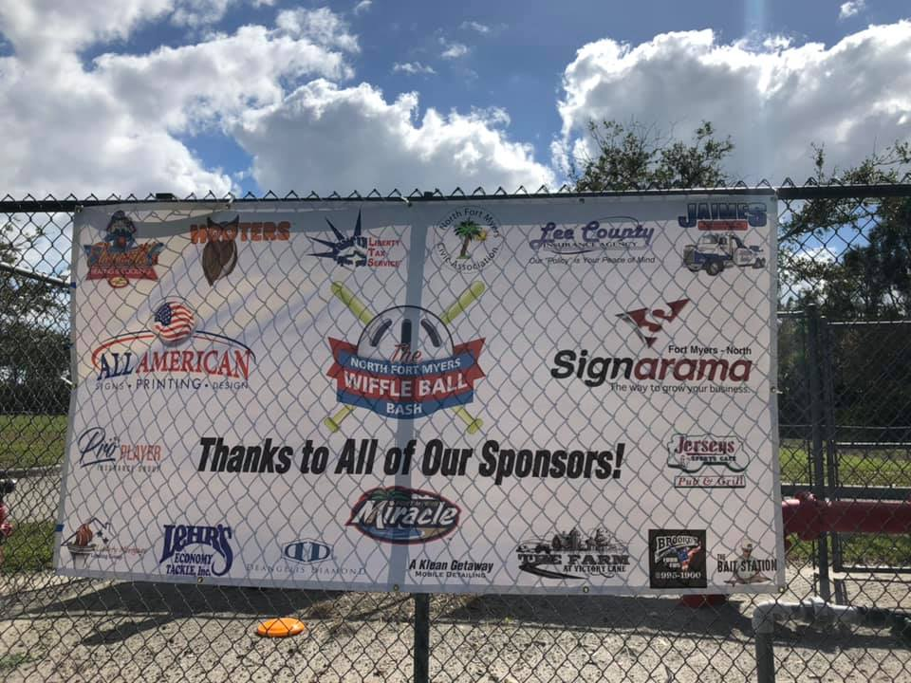 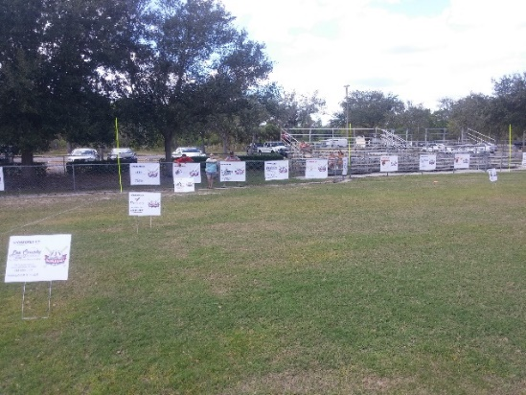

***The following sponsorship levels are available for the Whiffle Ball Bash:***

***Hall of Fame Level - Sponsorship terms subject to negotiation.***

**All-Star Level - $2500**

***Your All-Star Sponsorship includes****:*

. Tournament Naming Rights ( **EX:** The North Fort Myers Civic Association **ACME** Wiffle Ball Bash )

. Large Banner or Sign at entrance to facility

. Your business name or logo on all promotional material, and social media

. Your own advertising material (flags, banners, vehicles, ect.) within the entire complex

. 3 x 5 Banner on six (6) fields in prime location

. 2 Yard Signs on 3 remaining fields . 2 extra yard signs if business is not in NFM

. Large Logo in Middle of Sponsor Banner

. 2 Five (5) person teams in divisions of your choosing

. Numerous business recognition on the NFMCA Facebook Page

. Prime vendor space location / Trophies and Awards presentations at your tent

. Presenter at Awards Ceremonies with photos in front of large banner, sign, or business advertising

. Plaque for your business from the NFM Civic Association (presented at social)

. 2 year Business Membership in the North Fort Myers Civic Association ( If business is in NFM )

**Big League Level - $750 ( add a team for $75)**

***Your Big-League Sponsorship includes***:

. A Wiffle Ball Field named after your business or organization

. Large Banner or Sign in centerfield of your named field

. Design your field with your own advertising material

. Vendor space at your field behind home plate

. 2-Yard Signs located on 4 fields or 1 yard sign on all other fields . 1 extra yard sign if business is not in NFM

. Large Logo on Sponsor Banner

. Numerous business recognition on the NFMCA Facebook Page

. Plaque for your business from the NFM Civic Association (presented at Social)

. 1 year Business Membership in the North Fort Myers Civic Association ( If business is in NFM )

**Triple AAA Level - $500 (Add a team for $75)**

***Your Triple AAA Sponsorship includes:***

. 3 x 4 Banner on outfield fence of 2 fields

. Vendor space

. 1 Yard Sign on 3 fields .1 extra yard sign if business is not in NFM

. Logo on Sponsor Banner . Recognition on the NFMCA Facebook Page

. Plaque for your business from the NFM Civic Association (presented at social)

. 1 year Business Membership in the North Fort Myers Civic Association ( If business is in NFM )

**Double AA Level - $250**

***Your Double AA Sponsorship Includes:***

. 3 x 4 Banner on outfield fence of 1 field

. Vendor space

. 1 yard sign on 2 fields

. Logo on Sponsor Banner . Recognition on the NFMCA Facebook Page

. Framed certificate for your business from the NFM Civic Association (presented at social)

**Single A Level - $99**

***Your Single A Sponsorship Includes:***

. 3 x 4 Banner on outfield fence of 1 field

. Logo on Sponsor Banner . Recognition on the NFMCA Facebook Page

. Certificate for your business from the NFM Civic Association (presented at social)

**Gulf Coast League -$75**

. 1 Yard Sign on 1 field

**Vendor - $50**

. Vendor space (Non-Profit Vendors are no charge / must present non-profit certificate)

**Pre-Tournament Social Sponsor - $300**

**.** 3x 4 Banner at Social and on outfield fence of 1 field . Division named after your business . Vendor Space . Logo on sponsor banner . Recognition on the NFMCA Facebook Page . Framed Certificate for your business

. **Sponsors and Vendors are responsible for their own tents and contents of their vendor areas.**

***Personal Donations of any amount are also gladly accepted.***

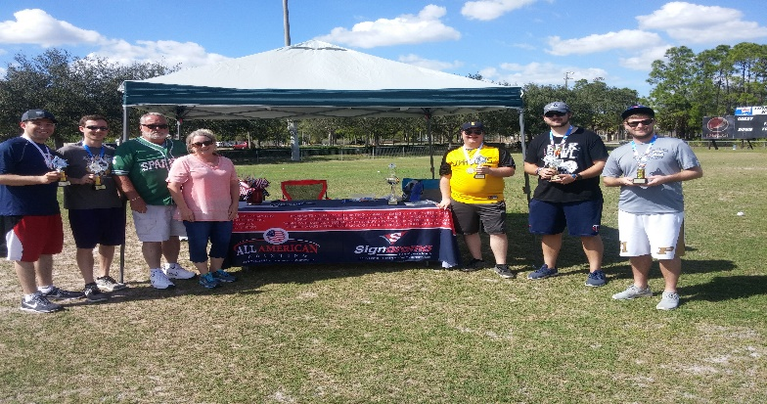

**How to Register as a Team or Player**

Teams or Individuals may register for the Whiffle Ball Bash by going to the North Fort Myers Civic Association Website at **NFMCIVIC.COM (2021 Online Registration will begin March 1, 2021)** and clicking on the *Whiffle Ball Bash* link. Simply follow the instructions on the site and on the form. A team/ player registration form for the Whiffle Ball Bash will be available as well as detailed instructions on how to submit your team/player registration form to enter. You can also email [NFMCDoug@gmail.com](mailto:NFMCDoug@gmail.com) or call 239-823-1388 and we will get you the form along with submission instructions as well. Teams and players from everywhere are welcome and encouraged to play in the Whiffle Ball Bash. You can submit your entry fee thru our pay-pal link on the website or send your payment via check or money order to:

**North Fort Myers Civic Association Whiffle Ball Bash**

**P.O. Box 3920**

**North Fort Myers, Florida 33918**

***Make check payable to: North Fort Myers Civic Association***

**How to Register as a Sponsor or Vendor**

Sponsors or Vendors may also register for the Whiffle Ball Bash by going to the North Fort Myers Civic Association Website at **NFMCIVIC.COM** and clicking on the *Whiffle Ball Bash* link. Simply follow the instructions on the site. You may also e-mail any questions to [NFMDoug@gmail.com or](mailto:NFMDoug@gmail.com%20or) call 239-823-1388 and we will get back with you. Sponsorship payment may also be made on the website using Pay-Pal or by check or money order to the above address.

Those wishing to apply for Hall of Fame thru Triple A sponsorship levels are strongly encouraged to contact Tournament Director Doug Dailey either by E-mail at [NFMDoug@gmail.com](mailto:NFMDoug@gmail.com) or by phone at (239)823-1388 for detailed information.

**\*How is No Base Running Made Possible at the Whiffle Ball Bash?**

Hits are determined as to where the batted ball comes to rest on the playing field. The playing field will be marked for Single, and Doubles, and Triples. If batted ball hits fence on the fly it is considered a triple, batted balls hit over fence are Home Runs. Runners are imaginary and are determined by where batted balls come to rest. Detailed Rules regarding imaginary base runners are included in the Official Whiffle Ball Bash Tournament Rules Packet to be issued to Team Captains prior to tournament play. Outs are made defensively by catching a fly ball or picking up a ball while still rolling on the ground prior to entering a hit zone area, or by strikeout.

**Fields and Equipment**

All required game equipment and field materials will be provided by the tournament.

Set-up and removal of fields will be handled by the volunteers of the North Fort Myers Civic Association.

**Contact Us**

For further information or questions regarding the Whiffle Ball Bash, please contact Tournament Director Doug Dailey by e-mail at: [NFMDoug@gmail.com](mailto:NFMDoug@gmail.com) or phone at (239) 823-1388. **NFMCivic.com**



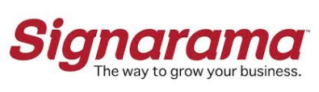

***North Fort Myers Civic Association / Signarama - North /All-American Printing Whiffle Ball Bash Tournament Hall of Champions***

***2019 – Piney Road Senators 2020 – Titan Crushers*** 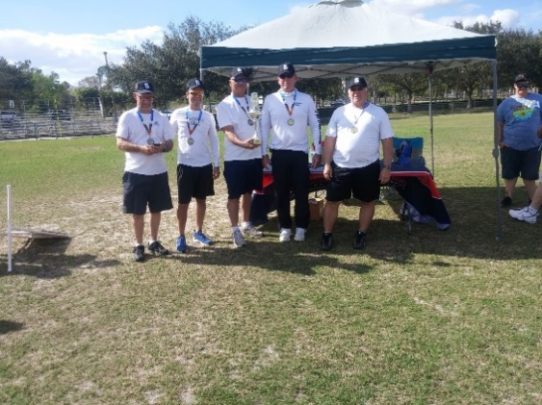

**Photos from the 2019 North Fort Myers Civic Association / Signarama - North/ All-American Printing / Whiffle Ball Bash**



