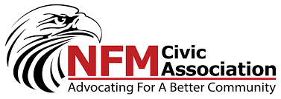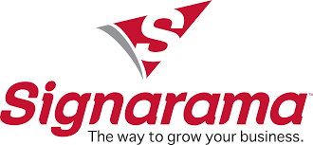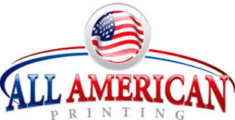

NORTH FORT MYERS CIVIC ASSOCIATION / SIGNARAMA-NORTH / ALLAMERICAN PRINTING
WHIFFLE BALL BASH
SPONSORSHIP DONATION APPLICATION FORM
YEAR OF EVENT: 20_____
- Name of Business:________________________________________________________

- Contact Person:__________________________________________________________

- Contact Email:___________________________________________________________

- Contact Phone:___________________________________________________________

- Type of Sponsorship Level: Please Place an “X” next to desired level(s):

All-Star ($2500)_____Big League( $750)_______AAA ($500)_____

AA($250)____ A($99)_____Gulf Coast($75)______Social ($300)______

Add a Team - Big League and AAA Sponsor only ($75)________

FOR DETAILED INFORMATION REGARDING SPONSORSHIP LEVELS PLEASE VISIT OUR WEBSITE AT
NFMCIVIC.COM
SPONSORSHIP DONATIONS CAN BE MADE ONLINE AT NFMCIVIC.COM OR BY MAIL TO:

North Fort Myers Civic Association
PO Box 3920
North Fort Myers Florida, 33918

Send Only Check or Money Order by Mail. NO CASH BY MAIL PLEASE.
Financing Options are available by contacting Tournament Director Doug Dailey by email at
NFMDoug@Gmail.com or by phone at 239-823-1388 and for any questions you may have.
The North Fort Myers Civic Association is a registered 501(C)3 Public Charity. Your donations are tax deductible

